E-Commerce Sales Analytics Dashboard
- Project Overview
This project analyzes e-commerce sales data using Power BI.
The dashboard provides insights into:
- Total Revenue
- Purchase Count
- Average Order Value
- Conversion Rate
- Revenue by Brand
- Revenue by Product Category
- Event Distribution
- Interactive Filtering

- Tools Used
  - Power BI
  - Power Query
  - DAX
  - Excel

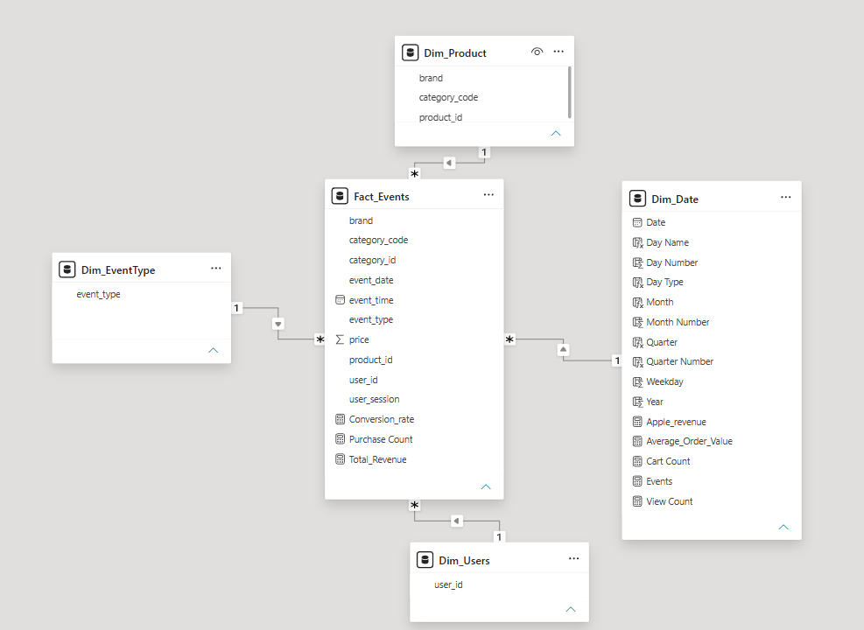
- Data Model
Star Schema:
a. Fact Table
- Fact_Events
b. Dimension Tables
- Dim_Product
- Dim_EventType
- Dim_Users
- Dim_Date

- KPIs
- Total Revenue
- Purchase Count
- Average Order Value
- Conversion Rate

- Dashboard Preview

- Executive Dashboard
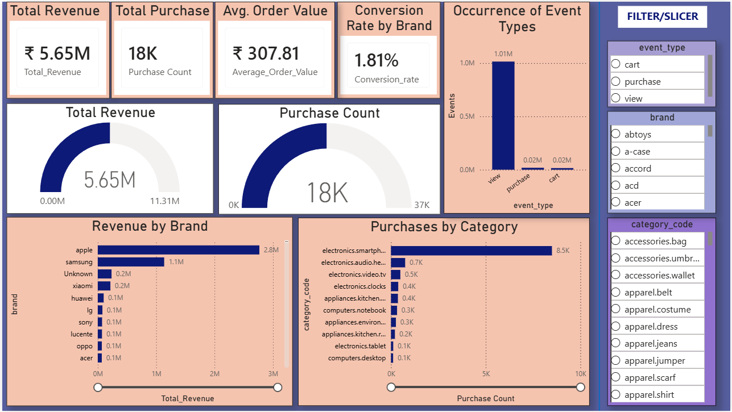

- Sales Analysis
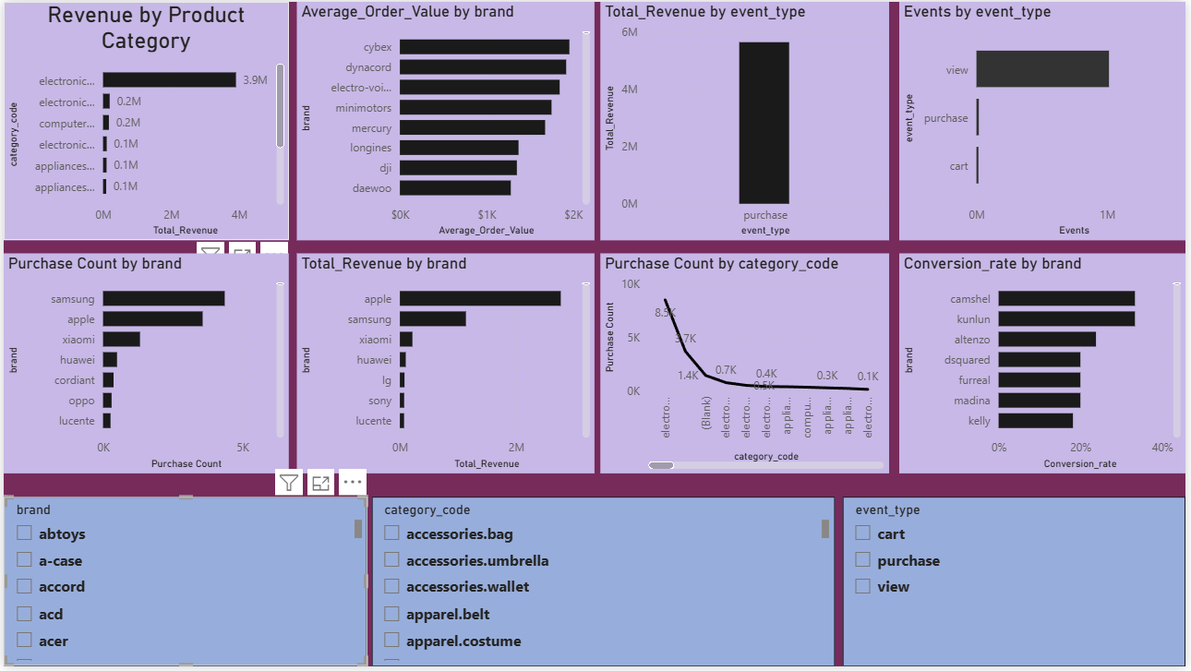

- Skills Demonstrated
- Data Cleaning
- Data Modeling
- Relationships
- DAX Measures
- KPI Design
- Dashboard Design
- Interactive Reporting

